Assignment Two: Steps 3 - 4

Adacel Technologies Limited

ACCT11059

Accounting, Learning and Online Communication

Stephanie Crass

Central Queensland University

# Step 3 – Restating our financial statements

After reading chapter 4, I was really nervous about starting to start the step of restating my company’s financial statements. However, I am quite confident with excel so was looking forward to getting in and playing around with the data to really understand all the juicy information restated financial statements provide about a company.

**Restating Movements in Equity**

I began Step 4 with restating my movements in equity. I found this step relatively straight forward with the help of Maria’s video on how to do this, it very easy to follow along with. I found that my company didn’t necessarily have all the items that hers had, mine seemed to be fairly basic. I only had one item that was classified as operating comprehensive income, ‘Exchange differences on translation of foreign operations.’ I had nothing to classify as financial comprehensive income. When I first input my financial statements for Assessment 1 Step 4, I included the ‘change in accounting policy’ and “restated total equity” for 2018 as separate line items, that was listed in my FY2019 annual report. I decided I didn’t need this listed separately in my spreadsheet and amended it to reflect that amount as my opening balance for 2018 instead. (Changes below).

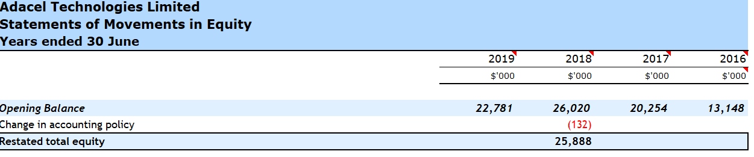

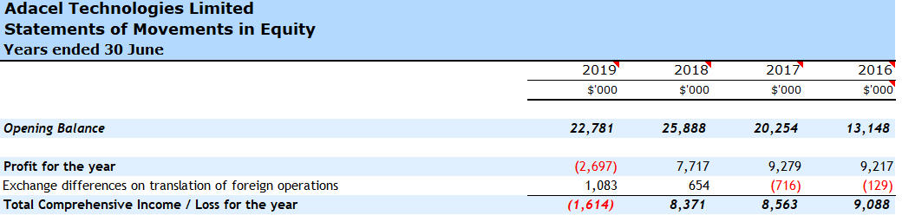

**Restating Balance Sheets**

I next started on restating my balance sheets. This step I found to more difficult. While Maria’s video was easy to follow along with, I did struggle with separating items into operating and financial assets and liabilities. The notes in the annual report did give me a more thorough understanding as to what each line item was, I still had some questions regarding what some of the items should be classified as. I first questioned ‘other financial assets’ under Current Assets, by looking further into the notes I found this item to be listed as ‘Restricted term Deposit with Royal Bank of Canada (“RBC”) and Bank of Montreal (“BMO”)’. Which was security for their rental premises. I assumed this to be a debt due to the payments to the two banks, so I classified this item as financial.

My next question related to ‘WIP and Inventories’ under Current Assets, further investigation into the annual report notes listed that these costs related to work-in-progress on contracts, which was easily allocated as an operational asset.

I also questioned what the accrued revenue items would consist of, which I again further investigated within the notes of the annual report. I found the accrued revenue include costs in the following:

* Trade receivables
* Sundry debtors
* Provincial tax credits
* Security deposits
* Prepayments

For this I decided to class that as O, because majority of these items were operational assets.

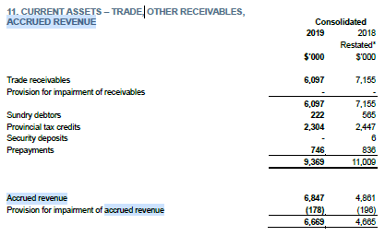

I then checked the notes for what the ‘Other financial assets’ listed under Non-Current Assets were so I could classify this line item correctly. I found that it too was for Security Deposits in Orlando and Hampton East offices. I believed this to be a financial asset.

I was unsure of what to classify ‘other liabilities’ to under current liabilities. Further investigation into the notes of the annual report listed this as Government grants. Which I thought might be a financial asset. I posted this question on the Facebook group in hopes someone else may have come across this also or have an idea as to what they believed it should be classified as. I unfortunately did not get a response back from anyone, so I continued with restating my financial statements and left as a financial asset.

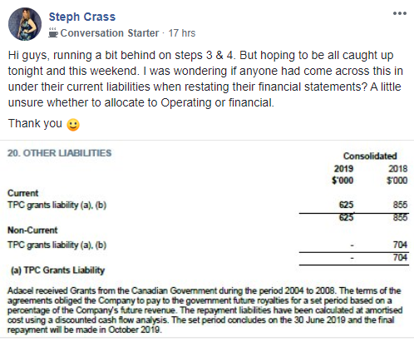

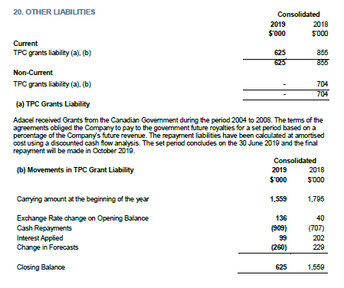

I decided to allocate that the non-current liabilities - ‘other non-current liabilities’ were classified as operating, because the notes in the annual report listed these items as retirement benefit obligations for employees. Screen show below.

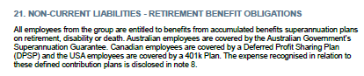

After separating my items between financial and operating, I began with linking my spreadsheet. I found this task to be easy, the formula’s seemed straight forward and I followed along with Maria’s videos while doing this. When I began splitting my ‘allocation of cash’ I decided to allocate 1% to operating and the rest to financial per Martyn’s study guide. I did wonder if the costs allocated to financial was too high a cost, with just allocating of 1% to operating.

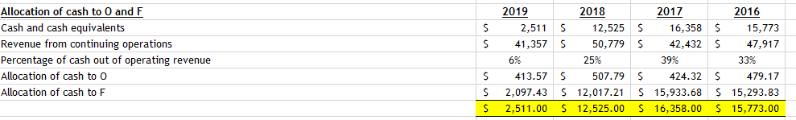

I followed everything else pretty well until I got to the final formula of ‘Net Financial Obligations + Equity’ which did not add up. Quickly I realised I had not correctly calculated for the ‘Net Financial Assets (NFA)’ by selecting the wrong cell. I was relieved when I was able to get this final equation to calculate correctly.

**Restating Income Statements**

Final financial statement to restate is my income statement, when Maria mentioned that this was the hardest step to do, I had an ‘Uh oh’ moment. Luckily, it wasn’t that terrifying after all, but slightly tedious. I didn’t have too much trouble trying to split the items between operating and financial. I didn’t have quite so many items under my income statements, unlike Maria with her income statements. I had no financial comprehensive income, so I have left this section blank. But wanted to include it in my spreadsheet so that the markers were able to see that.

I used the Australian company income tax rate, after making sure my company was based in Australia. Even though my company operates worldwide. I found the equations to be easy to follow and was fortunate to have my totals add up on the first go this time, unlike the previous step.

Overall, I was happy with how I handled this task. I was pleasantly surprised to find it was not as hard as I thought when I first read Chapter 4. I enjoyed working with excel, as I use this daily in my full-time job. I didn’t struggle with the formula’s like I initially thought I would when reading the chapter material. I was very glad that Maria Tyler had explained each of these steps with videos, they were very easy to follow along with, and I don’t think I would have been able to complete this step without them.